
Git Cheat Sheet

The essential Git commands & info every developer must know

Table of Content

What is Git ? 3
Definition 3
Key concepts of Git: 3
Stages of changes 4
Stages 4
Creating Snapshots 5
Initializing a repository 5
Staging files 5
Viewing the status 5
Committing the staged files 5
Skipping the staging area 5
Removing files 5
Renaming or moving files 5
Viewing the staged/unstaged changes 6
Viewing the history 6
Viewing a commit 6
Unstaging files (undoing git add) 6
Discarding local changes 6
Restoring an earlier version of a file 7
Browsing History 8
Viewing the history 8
Filtering the history 8
Formatting the log output 8
Creating an alias 8
Viewing a commit 8
Comparing commits 8
Checking out a commit 9
Finding a bad commit 9
Finding contributors 9
Viewing the history of a file 9
Finding the author of lines 9
Tagging 9
Branching & Merging 10
Managing branches 10
Comparing branches 10
Stashing 10
Merging 10
Viewing the merged branches 11
Rebasing 11
Cherry picking 11
Merging types 11
Collaboration 12
Cloning a repository 12
Syncing with remotes 12
Sharing tags 12
Sharing branches 12
Managing remotes 12
Rewriting History 13
Undoing commits 13
Reverting commits 13
Recovering lost commits 13
Amending the last commit 13
Interactive rebasing 13
Amending the earlier commit 13

What is Git ?

Definition
Git is a decentralised version control system. It records all the changes made to our code over time in the special database called repository. Via this history we can see how changes were made, what changes were made and why/when changes were applied.

Key concepts of Git:
- Without Git we would store dedicated folder for the each project version like: v1.0.0, v1.0.1 and then merge them manually
- Allows to work together: to work simultaneously on the same feature development
- Git remembers the entire history of any changes made to the repository
- Git is immutable: so when you are changing the commit message or renaming the branch, then new entity with the same characteristics as the original gets created
- Git is a distributive VCS (version control system): every worker/team member has its own copy of the project on his machine with the entire history and changes, this way it’s way more reliable than centralized VCS’s like TFS
- Head is a pointer to the branch where we currently are located (currently checked-out branch)
- Git under the hood represents a bunch of sequential nodes(commits) linked with each other. Branches are represented as pointers to the specific nodes. And on top of the branch pointers there must stand the Head pointer
- Checking-out of some branch is no more than just moving of the Head pointer

Stages of changes

Stages
- Working directory
- Staging area
- Local repository (index)
- Remote repository
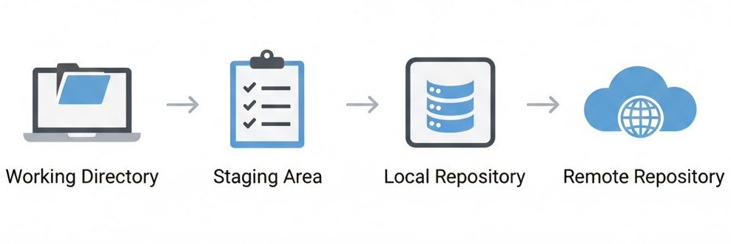
Transferring between changes
- Initially created unit of work (file, folder, etc.) or update unit of work goes to the working directory.
- After running “git add <match unit of work>” all the matched items will be added to the staging area. This stage isn’t connected with the neither local or remote repository, so the changes in this stage are needed as a preparation to be introduced to the repository, intermediate step.
- To the local repository will go all the units of work ONLY from the Staging area by running “git commit -m "<commit message>"”. Changes in this area stays independent from the states of the previous stages in the hierarchy (example: some files that previously were committed can be deleted in the working directory and after that to be recovered from the local repository). Local repository represents the same repository that many people can access remotely with one difference, that it’s not the actual repository from the remote, it’s your local copy of it that can be therefore integrated/pushed with the remote one.
- Only after running “git push” your local repository instance is integrated with the remote repository. All the changes from your local instance are pushed and become the publicly accessible changes.

Creating Snapshots

Initializing a repository
git init

Staging files
git add file1.js # Stages a single file
git add file1.js file2.js # Stages multiple files
git add *.js # Stages with a pattern
git add . # Stages the current directory and all its content

Viewing the status
git status # Full status
git status -s # Short status

Committing the staged files
git commit -m “Message” # Commits with a one-line message
git commit # Opens the default editor to type a long message

Skipping the staging area
git commit -am “Message” # Works only when changes added were not untracked at all

Removing files
git rm file1.js # Removes from working directory and staging area
git rm --cached file1.js # Removes from staging area only

Renaming or moving files
git mv file1.js file1.txt

Viewing the staged/unstaged changes
git diff # Shows unstaged changes
git diff --staged # Shows staged changes
git diff --cached # Same as the above

Viewing the history
git log # Full history for the branch
git log --oneline # Summary for the branch
git log --reverse # Lists the commits from the oldest to the newest
git log --all # Lists all the commits among all branches
git log --graph # Builds graph with all the branches and commits
git log --all --oneline --graph

Viewing a commit
git show 921a2ff # Shows the given commit
git show HEAD # Shows the last commit
git show HEAD~2 # Two steps before the last commit
git show HEAD:file.js # Shows the version of file.js stored in the last commit

Unstaging files (undoing git add)
git restore --staged file.js # Unstages file.js from the staging are to the working dir

Discarding local changes
git restore file.js # Copies file.js from index to working directory
git restore file1.js file2.js # Restores multiple files in working directory
git restore . # Discards all local changes (except untracked files)
git clean -fd # Removes all untracked files

Restoring an earlier version of a file
git restore --source=HEAD~2 file.js

Browsing History

Viewing the history
git log --stat # Shows the list of modified files
git log --patch # Shows the actual changes (patches)

Filtering the history
git log -3 # Shows the last 3 entries git log --author=“Mosh”
git log --before=“2020-08-17” git log --after=“one week ago”
git log --grep=“GUI” # Commits with “GUI” in their message
git log -S“GUI” # Commits with “GUI” in their patches
git log hash1..hash2 # Range of commits
git log file.txt # Commits that touched file.txt

Formatting the log output
git log --pretty=format:”%an committed %H”

Creating an alias
git config --global alias.lg “log --oneline"

Viewing a commit
git show HEAD~2
git show HEAD~2:file1.txt # Shows the version of file stored in this commit

Comparing commits
git diff HEAD~2 HEAD # Shows the changes between two commits
git diff HEAD~2 HEAD file.txt # Changes to file.txt only

Checking out a commit
git checkout dad47ed # Checks out the given commit
git checkout master # Checks out the master branch
git checkout -b feature-1 # Creates and checkouts branch feature-1

Finding a bad commit
git bisect start
git bisect bad # Marks the current commit as a bad commit
git bisect good ca49180 # Marks the given commit as a good commit
git bisect reset # Terminates the bisect session

Finding contributors
git shortlog

Viewing the history of a file
git log file.txt # Shows the commits that touched file.txt
git log --stat file.txt # Shows statistics (the number of changes) for file.txt
git log --patch file.txt # Shows the patches (changes) applied to file.txt

Finding the author of lines
git blame file.txt # Shows the author of each line in file.txt

Tagging
git tag v1.0 # Tags the last commit as v1.0
git tag v1.0 5e7a828 # Tags an earlier commit
git tag # Lists all the tags
git tag -d v1.0 # Deletes the given tag

Branching & Merging

Managing branches
git branch bugfix # Creates a new branch called bugfix
git checkout bugfix # Switches to the bugfix branch
git switch bugfix # Same as the above
git switch -C bugfix # Creates and switches
git branch -d bugfix # Deletes the bugfix branch

Comparing branches
git log master..bugfix # Lists the commits in the bugfix branch not in master
git diff master..bugfix # Shows the summary of changes

Stashing
git stash push -m “New tax rules” # Creates a new stash
git stash list # Lists all the stashes
git stash show stash@{1} # Shows the given stash
git stash show 1 # shortcut for stash@{1}
git stash apply 1 # Applies the given stash to the working dir
git stash drop 1 # Deletes the given stash
git stash clear # Deletes all the stashes

Merging
git merge bugfix # Merges the bugfix branch into the current branch
git merge --no-ff bugfix # Creates a merge commit even if FF is possible
git merge --squash bugfix # Performs a squash merge
git merge --abort # Aborts the merge
git merge --ff-only bugfix # Allows only fast-forward merge, otherwise discard

Viewing the merged branches
git branch --merged # Shows the merged branches
git branch --no-merged # Shows the unmerged branches

Rebasing
git rebase master # Changes the base of the current branch

Cherry picking
git cherry-pick dad47ed # Applies the given commit on the current branch

Merging types

- Fast-forward = simply move forward the MASTER pointer to the BUGFIX (merge when the last commit of the MASTER is the first commit of the BUGFIX and the result of this operation is moving the pointer)
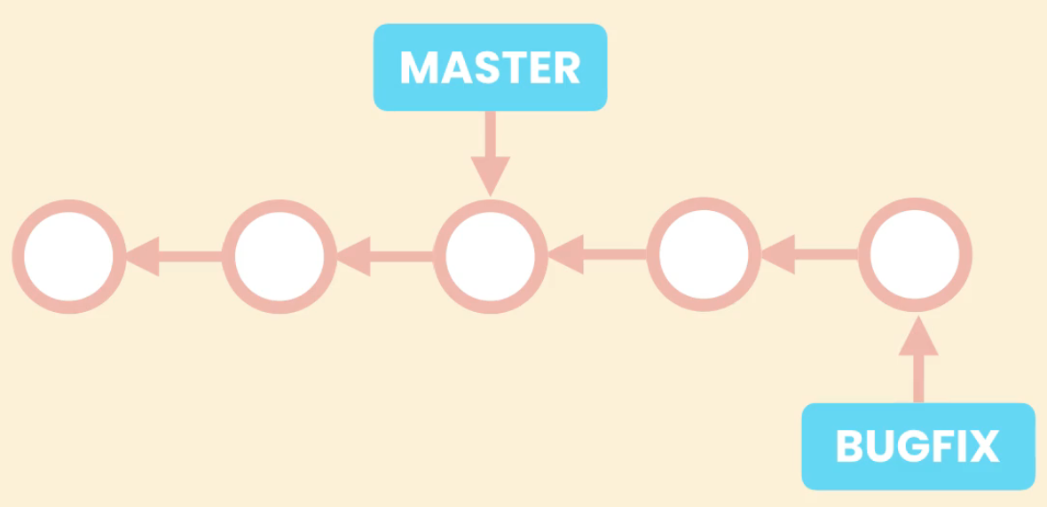CodeWithMosh/ultimate-git-course
- 3-way merge = movement further of the MASTER pointer is not possible to the BUGFIX without losing the commits from the BUGFIX (merge when the last commit of MASTER is NOT the first commit of the BUGFIX and the result of it is the new commit called merge commit)
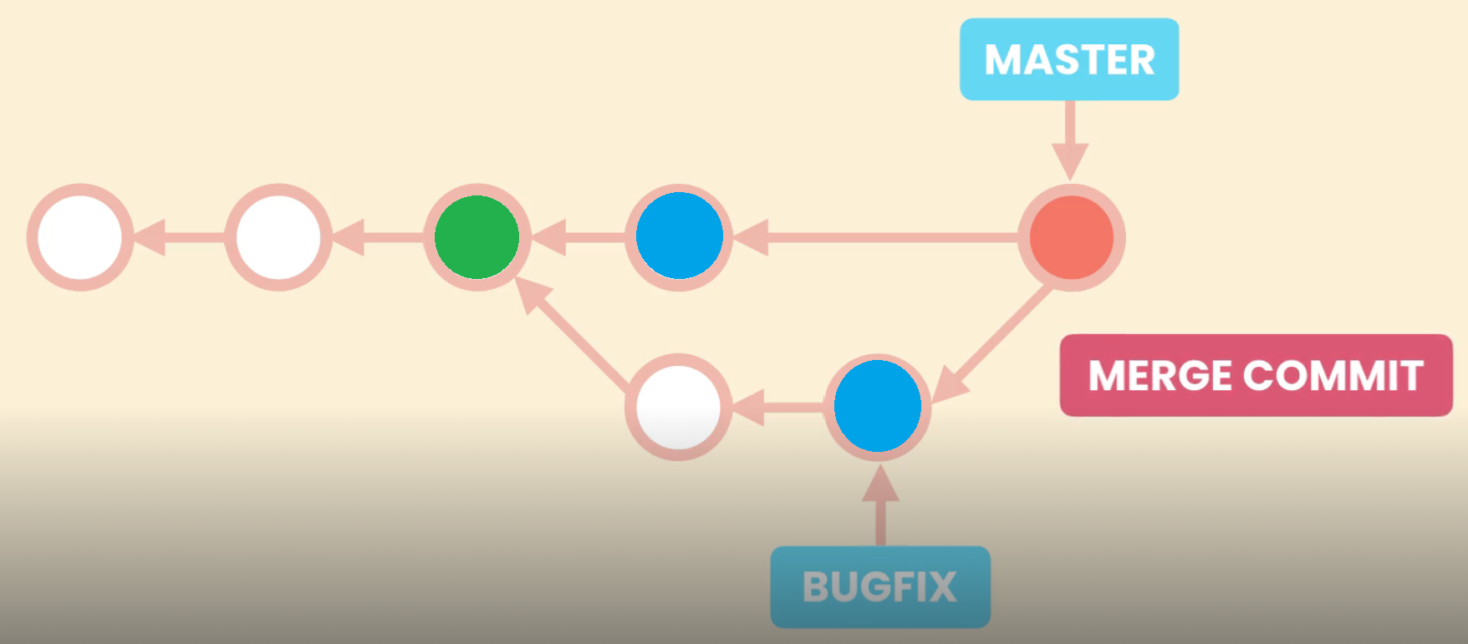CodeWithMosh/ultimate-git-course
(3-way merge since is based on the green circle - last MASTER commit in the BUGFIX branch and on the blue circles that are last commits in MASTER and BUGFIX)

Collaboration

Cloning a repository
git clone url

Syncing with remotes
git fetch origin master # Fetches master from origin
git fetch origin # Fetches all objects from origin
git fetch # Shortcut for “git fetch origin”
git pull # Fetch + merge
git push origin master # Pushes master to origin
git push # Shortcut for “git push origin master”

Sharing tags
git push origin v1.0 # Pushes tag v1.0 to origin git push origin —delete v1.0

Sharing branches
git branch -r # Shows remote tracking branches
git branch -vv # Shows local & remote tracking branches
git push -u origin bugfix # Pushes bugfix to origin
git push -d origin bugfix # Removes bugfix from origin

Managing remotes
git remote # Shows remote repos
git remote add upstream url # Adds a new remote called upstream
git remote rm upstream # Remotes upstream

Rewriting History

Undoing commits
git reset --soft HEAD^ # Removes the last commit, keeps changed staged
git reset --mixed HEAD^ # Unstages the changes as well
git reset --hard HEAD^ # Discards local changes
git reset --hard ORIG_HEAD # Reset to the moment before merge/rebase was performed

Reverting commits
git revert 72856ea # Reverts the given commit
git revert HEAD~3.. # Reverts the last three commits
git revert --no-commit HEAD~3.. # Creates only 1 revert message

Recovering lost commits
git reflog # Shows the history of HEAD
git reflog show bugfix # Shows the history of bugfix pointer

Amending the last commit
git commit --amend # Allows to change the commit message and to add additional changes if the staging are at the moment of amending isn’t empty

Interactive rebasing
git rebase -i HEAD~5

Amending the earlier commit
- git rebase -i HEAD~3
- Instead of “pick” option to the certain commit just pass “e” or “edit” in the opened window for the interactive rebase

